Analysis of the Clinical Pathways Creator

**1 Introduction**

There are three main aims in this document. Firstly, the document will reflect our understanding about the Clinical Pathways Creator system, including the creator part and the NLP part. Secondly, through this document we can confirm a common view about our projects. Finally, we hope that our incorrect understanding and problems will be found through this document.

**2 Data flow**

Reference documents will be uploaded into Corpus by users. When users search clinical information through the search function in the Clinical Pathway Editor, another system named NLP will collect and analysis the information automatically from the Corpus based on the search task and then return the useful information to users. Finally, the Clinical Pathway will be saved in the form of JASON data, which can be used by other devices, such as mobile phone and laptop.

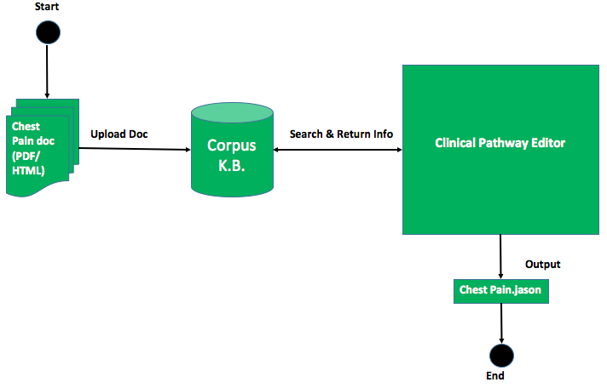

Figure 1 Data Flow

**3 Screen flow**

There are 7 screens in this system. They are login screen, choose file screen, upload screen, choose existing pathway screen, pathway editor screen, information feedback screen and saving screen. The screen flow below shows how these screens communicate with each other.

1. On the login screen (1) when a user clicks the upload doc button, the choose file screen (2) will be shown for the user choosing the reference. After the user chose the reference and clicked the choose button, the screen will move to the upload screen (3).
2. On the upload screen (3), users can choose to edit existing pathway (4) or create a new one. Then the screen will move to the pathway editor screen (5).
3. The pathway editor screen (5) can search helpful information through the NLP system, then a pop-up screen named feedback screen (6) will display the information returned from the NLP.
4. After editing, users can save the pathway by clicking the save button on the pathway editor screen (5). The pop-up saving screen (7) will be shown.

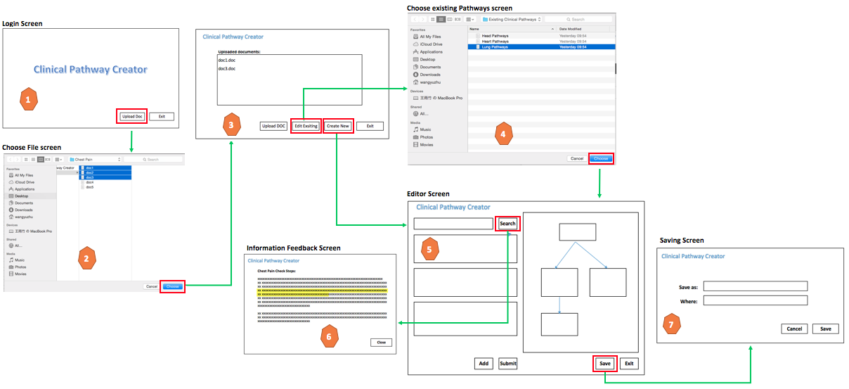

Figure 2 Screen Flow

**4 Analysis of each step**

**4.1 Login**

This is the first screen of this system, there are to buttons on this screen. One is the Upload Doc button, which can move to the upload doc screen after clicked it. The other one is the Exit button, users can exit the system by pushing this button.

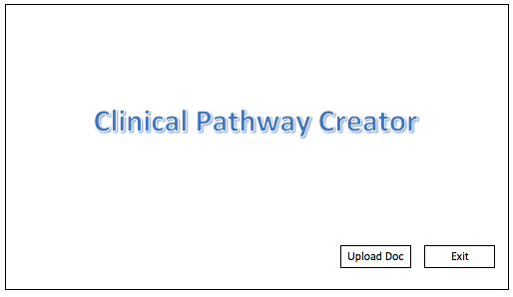

Figure 3 Login Screen

**4.2 Upload Documents**

The uploaded files will be shown on this screen, also user can add new files or delete the existing files. There are two buttons can move to the editor screen, the Edit Existing button and the Create New button. When users clicked the Edit Existing button, users can choose the existing clinical pathway then move to the editor screen. While when users clicked the Create New button, the screen will move to the editor screen directly.

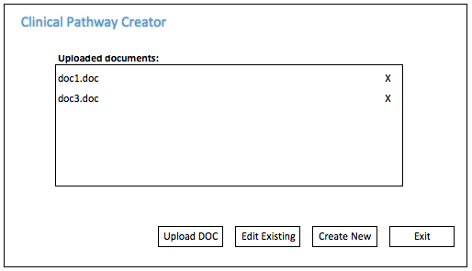

Figure 4 Upload Screen

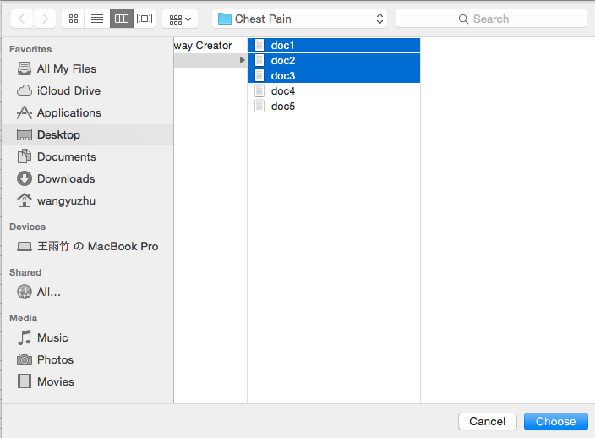

Figure 5 File Choose Screen

**4.3 Editor Screen**

Figures below show the clinical pathways structure. There are questions to confirm the situation of the patient and then give advice to the doctor to help the doctor making decision. The clinical pathways are not the simple linear or tree structure, they are process, like maps or iterations.

The solution of clinical pathways editor includes two main parts. One is the editor part where the user can input the data of the pathway and build the pathway. The other is a part that displays the pathway made by user in a graphic way. The existing solution uses the risk scores (plan 1) to decide the next step. The other solution (plan 2) is an improved version. Obviously, these two plans are a little complicated, but now we still have not found a better way to improve the existing solution.

**4.3.1 Edit Part**

Plan 1: Risk Score

This is the existing solution of the clinical pathways creator project. Users give risk score to each answer and the next step depends on the risk score. An example below illustrates that according to the answer the risk score is from 0 to 6. When the score is less than 3 the next step will be step A, when the score is between 4 and 5 then the next step will go to B, if the final score is more than 5 the next step will be C. Two main points of this solution are the risk score and the exit condition.

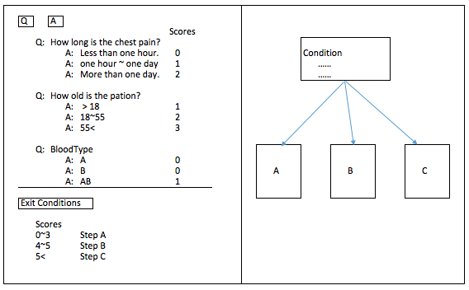

Figure 6 Plan 1

Plan 2: Four **+** Advanced

This is an improved version of plan 1. Sometimes the answer could be yes or no, an example below shows that the three questions could be answered as yes to all, no to all, yes to any and no to any. Users can decide the next step based on the four situations which is easier than plan 1. However, most of the clinical pathways are complicated that cannot be simply answered by yes or no. If there are non-Y/N questions users can add an advanced step which use the same solution as plan 1.

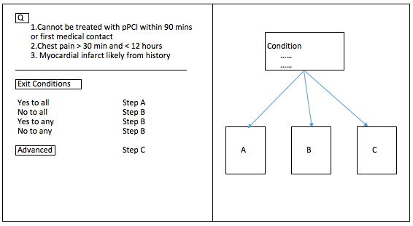

Figure 7 Plan 2

Plan 3: Coming soon……

**4.3.2 Display Part**

The right part is called display part, which is used to show the whole structure of the pathway created by users. This part can provide users with the clear image of the pathway directly. Users can select the node of the pathway which they want to edit, then the data of the node will be shown at the edit (left) part.

**4.3.3 Saving Screen**

The saving screen is designed to save the pathway. Users can edit the name and the saving path of the pathway. The file will be saved in the form of xxx.jason.

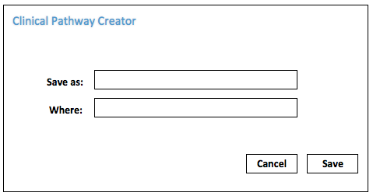

Figure 8 Saving Screen

**4.3.4 Display Information**

There is a search function in the pathway editor screen, users can get relevant clinical information from the NLP system which will be discussed in the next section. Information returned from the NLP system will be displayed on the Information Display Screen below, also, the important part will be highlighted. Users can refer and copy the information to create pathways.

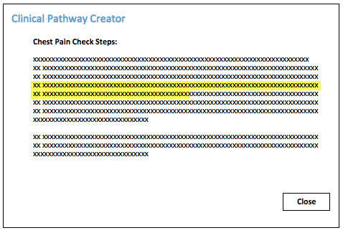

Figure 9 Information Display Screen

**4.4 Analysis of NLP**

NLP …